LAPTOP REQUEST CATALOG ITEM

## Team Id: NM2025TMID14635

**Team Members: 4**

**Team Leader :** HEMANTHINI.P **Team Member :** YUVASRI.B **Team Member :** SATHYAPRIYA.V **Team Member :** DHARSHINI.V

## PROBLEM STATEMENT:

Employees in the organization require a fast and efficient method to request laptops for work purposes. The existing process is manual, often resulting in delays and a lack of dynamic form behavior to assist users or ensure accurate data input.

To resolve this issue, a Service Catalog item should be developed to enable users to request laptops easily. This form should include dynamic fields, clear guidance, and features such as the ability to reset the form when needed. Additionally, the solution must support full change tracking to ensure proper governance and deployment management.

**Skills:**

Designed and implemented dynamic Service Catalog items for hardware requests using ServiceNow. Configured client scripts, UI policies, and catalog UI pages for user-friendly form behavior.Ensured data accuracy with field validations, dependencies, and conditional logic. Enabled audit tracking and approval workflows to support governance and compliance.

## Milestone 1: Update set Create Local Update set

1. Launch ServiceNow.
2. Navigate to All, then use the search bar to look for Update Sets.
3. Under the System Update Sets section, click on Local Update Sets.
4. Hit the New button to create a new update set.
5. Enter the necessary details and name the update set "Laptop Request”
6. Click on submit and make current.

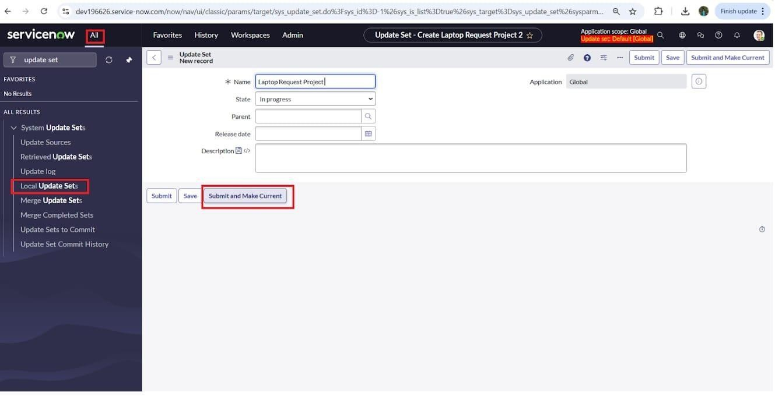

## Milestone 2:Service Catalog Item Activity 1: Create Service Catalog Item:

* 1. Launch ServiceNow.
  2. Go to All and search for Service Catalog.
  3. Under Catalog Definitions, choose Maintain Items.
  4. Click New to create a new catalog item.

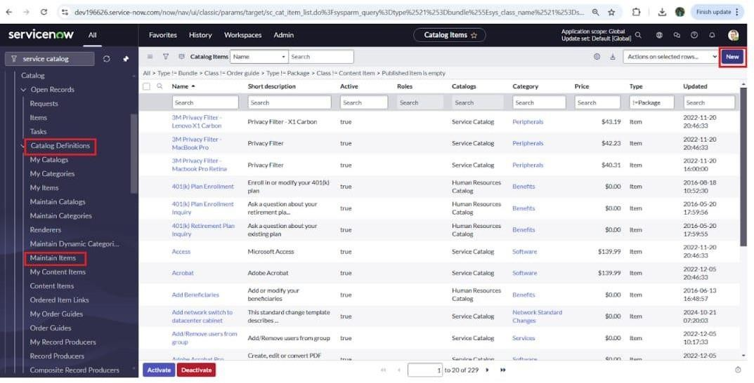

1. Enter the necessary information to set up a new catalog item:
2. Name: Laptop Request
3. Catalog: Service Catalog
4. Category: Hardware
5. Short Description: Use this form to request a new laptop
6. Once all details are filled in, click Save to store the item.

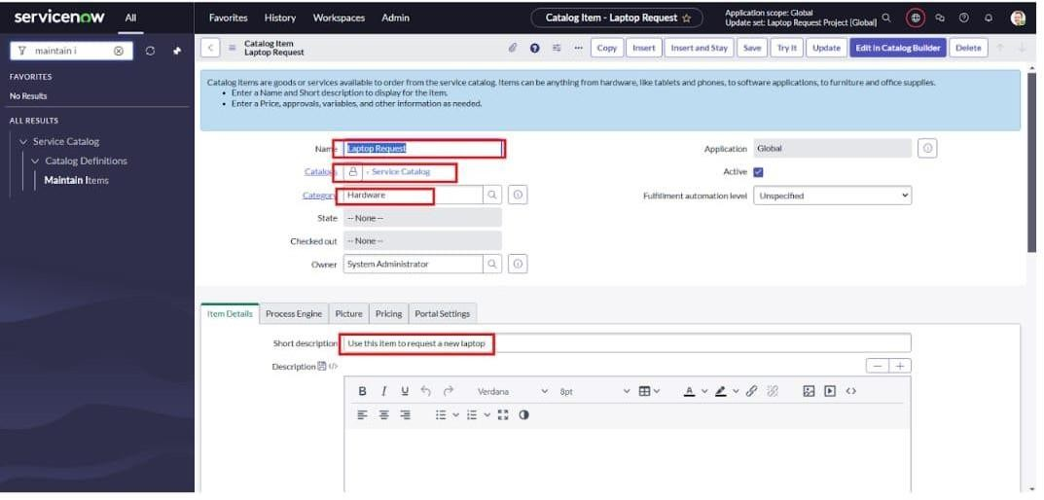

## Activity 2: Add variables Step1:

* + After saving the catalog item, scroll down to the Related Lists section and click on Variables.
  + Click New and fill in the following details:
    1. Variable 1:
       - Label: Laptop Model
       - Type: Single Line Text
       - Name: laptop_model
       - Order: 100
  + Click Submit to save the variable.
  + Repeat the New process to add the remaining variables using the same steps.

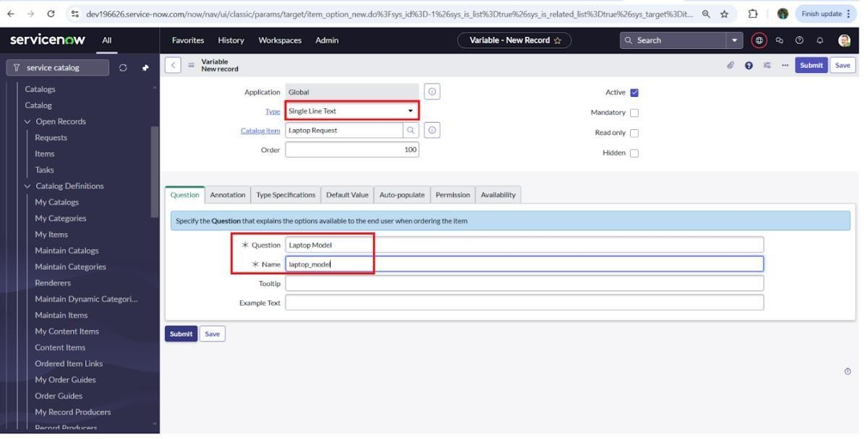

* + 1. Variable 2:Justification Type: Multi line text Name: justification Order:200
    2. Variable 3:Additional Accessories Type: Checkbox

Name: additional_accessories Order:300

* + 1. Variable 4: Accessories Details Type: Multi line text Name:accessories_details Order:400

## Step2:

* After adding above variable which are added to newly created catalog item
* Then save the catalog item form

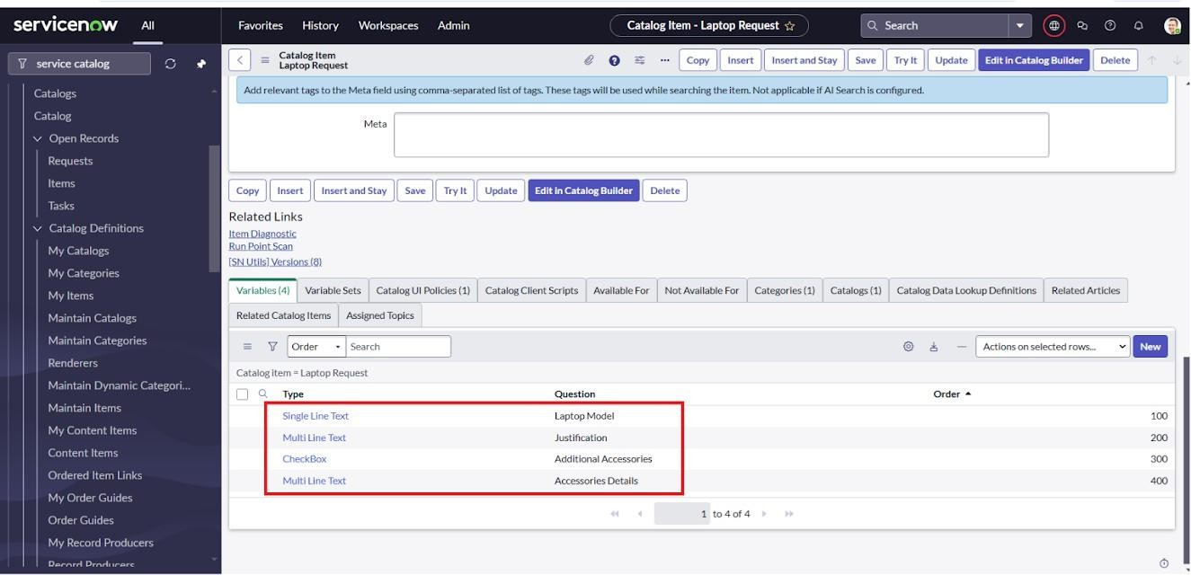

## Milestone 3: UI Policy

**Activity 1: Create Catalog Ui policies**

1. Go to All, then search for Service Catalog.
2. Under Catalog Definition, click on Maintain Items.
3. Find the previously created catalog item named Laptop Request.
4. Open the Laptop Request item, scroll down, and click on the Catalog UI Policies tab.
5. In the Catalog UI Policies related list, click New to create a new policy.
6. Enter the Short Description as: Show Accessories Details.
7. Under the When to Apply section, set the condition as:
8. Field: additional_accessories
9. Operator: is
10. Value: true
11. Click Save (do not click Submit yet).
12. Scroll down to the Catalog UI Policy Actions section and click New.
13. Set the following values:
14. Variable Name: accessories_details
15. Order: 100
16. Mandatory: True
17. Visible: True
18. Click Save, then click Save again on the main Catalog UI Policy form to apply the changes.

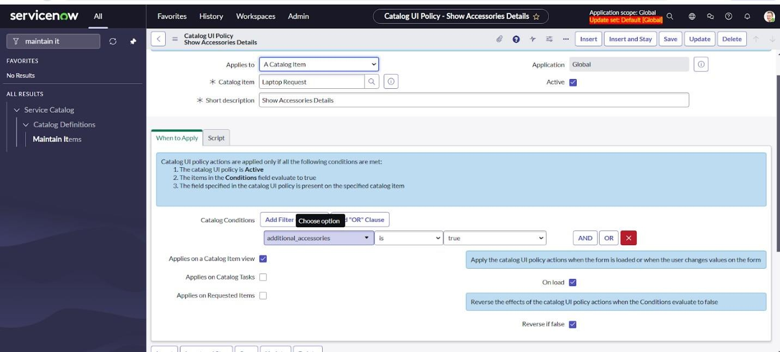

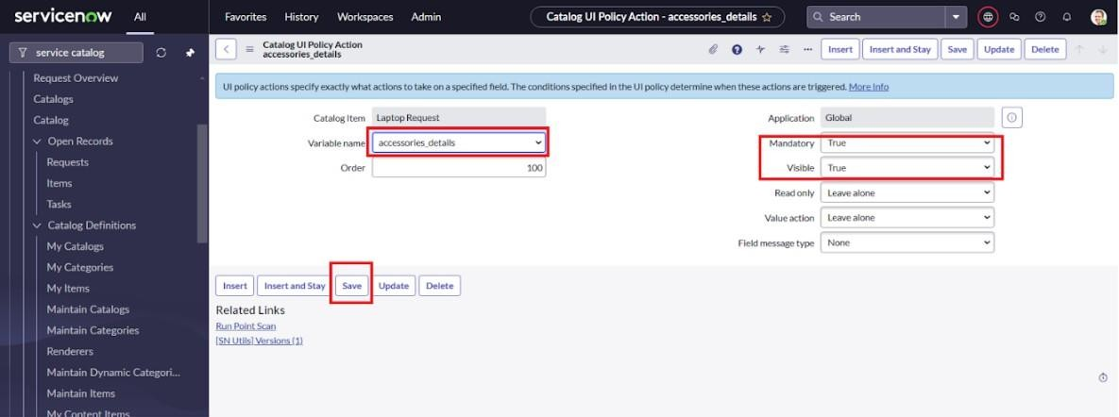

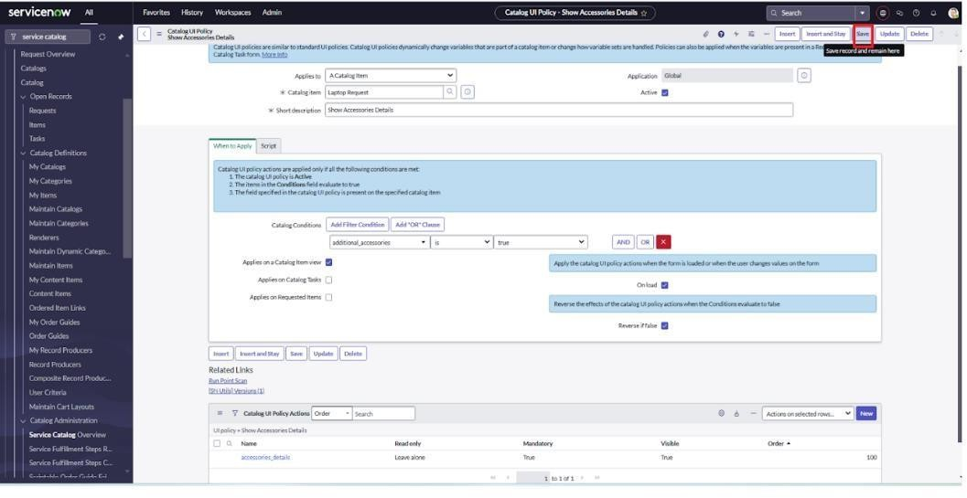

**Milestone 4: UI action**

# Activity 1: Create ui action

1. Log in to ServiceNow.
2. Navigate to All, then search for UI Action in the filter navigator.
3. Under System Definition, click on UI Actions.
4. Click the New button to create a new UI Action.
5. Fill in the following details:
   * Table: Shopping Cart (sc_cart)
   * Order: 100
   * Action Name: Reset form
   * Client: Check the box to enable it as a client-side action
6. In the Script section, enter the following code:

function resetForm() { g_form.clearForm(); // Clears all form fields alert("The form has been reset.");

}

1. Save the UI Action to apply your changes.

Click on save

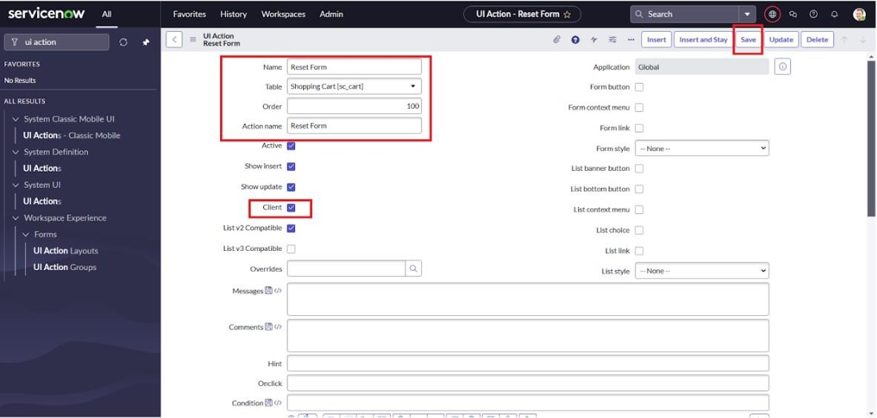

## Milestone 5: Export Update set

**Activity 1: Exporting changes to another instances**

1. Go to All, then search for Update Sets in the navigation filter.
2. Click on Local Update Sets.
3. Open the update set you created earlier, named "Laptop Request Project".
4. Change the State field to Complete.
5. Under the Updates tab in the related list, you can view all the changes made as part of this update set.
6. Click on export to XML ,it download file

.

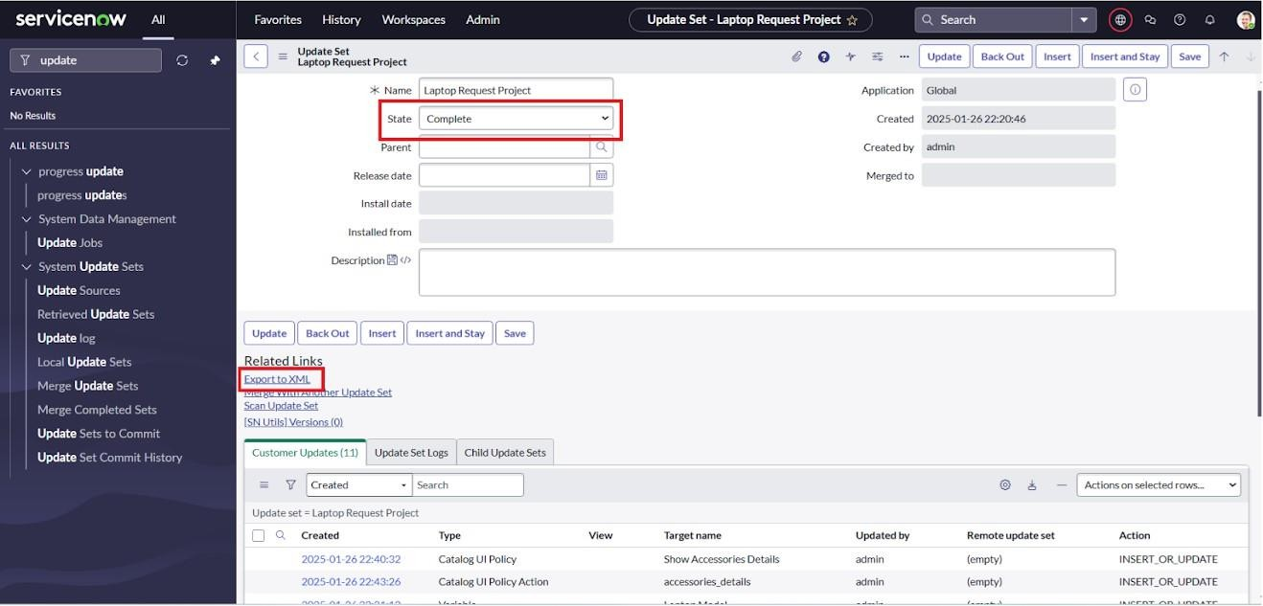

# Milestone 6: Login to another Instance Activity 1: Retrieving the update set

1. Open a new incognito browser window and access another ServiceNow instance**.**
2. Log in using your credentials.
3. Navigate to All, then search for Update Sets.
4. Click on Retrieved Update Sets under the System Update Sets section.
5. This will display the list of retrieved update sets — scroll down to continue.
6. Click on Import Update Set from XML.
7. Select and upload the previously downloaded XML file**.**
8. Hit Upload — the update set will now be added to the instance.
9. Open the retrieved update set named **"**Laptop Request Project**"**.
10. Click on Preview Update Set to review the changes.
11. After reviewing, click on Commit Update Set to apply it.
    1. And also see the related tab updates
    2. After commiting update set in this instance we get all updates which are done in the previous instance

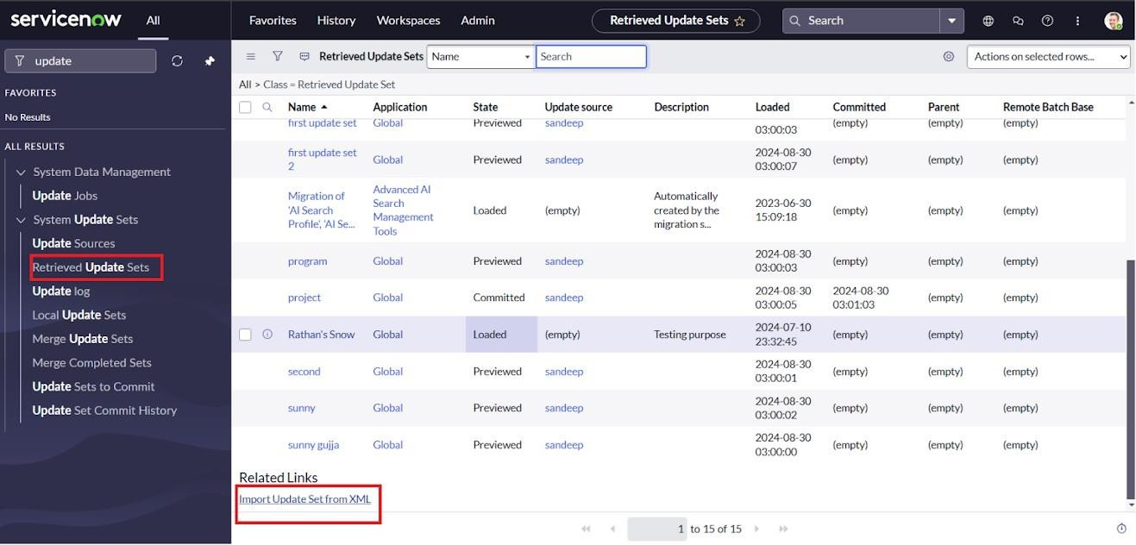

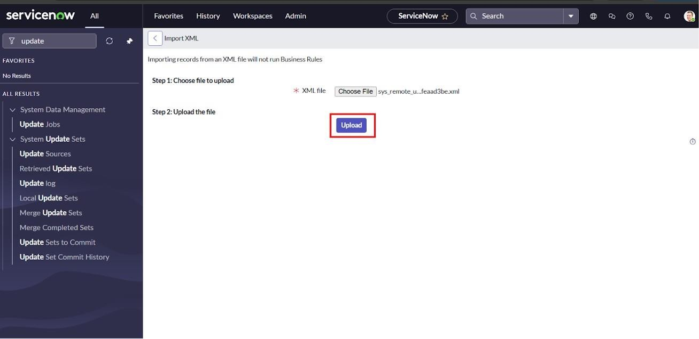

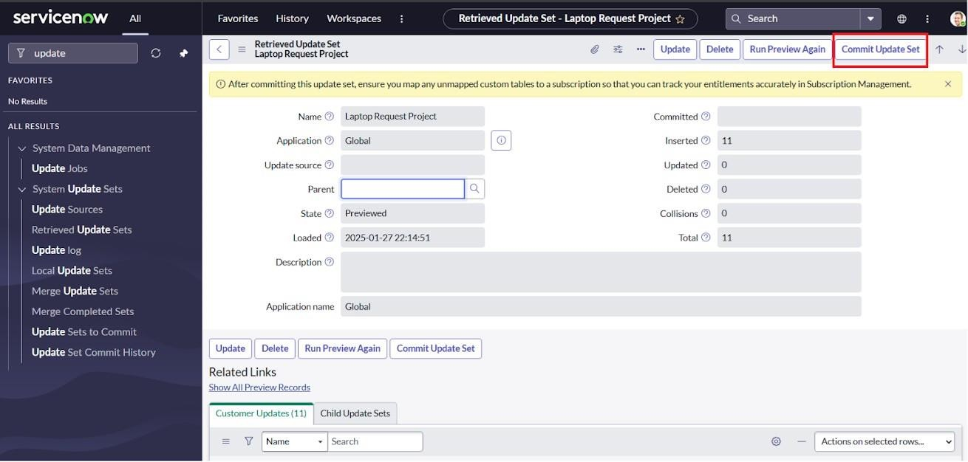

# Milestone 7: Testing

## Test Catalog Item

1. In the target instance, go to the Application Navigator and search for Service Catalog**.**
2. Under Service Catalog, click on Catalog**.**
3. Open the Hardware category and search for the Laptop Request item.
4. Click to open the Laptop Request catalog item.
5. You will initially see only three variables displayed.
6. According to our setup, when the Additional Accessories checkbox is selected, the Accessories Details field should appear and become mandatory.
7. Review the behavior — it works as expected and meets the requirements.

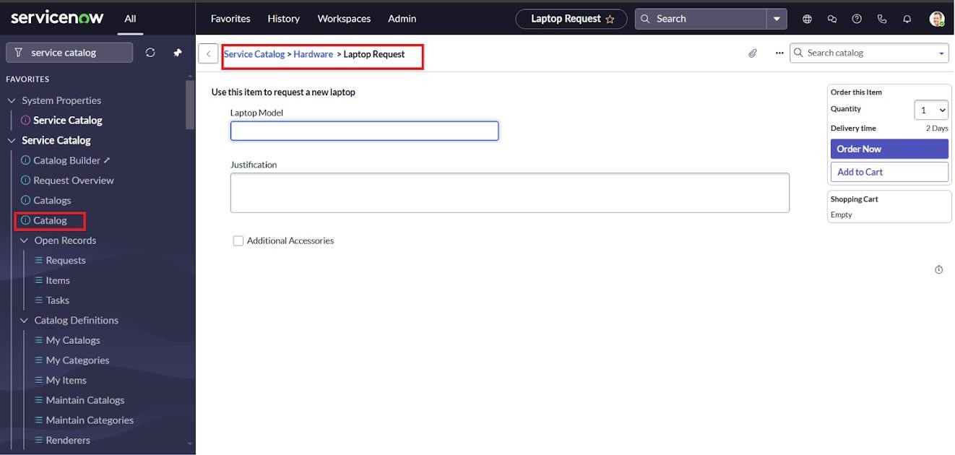

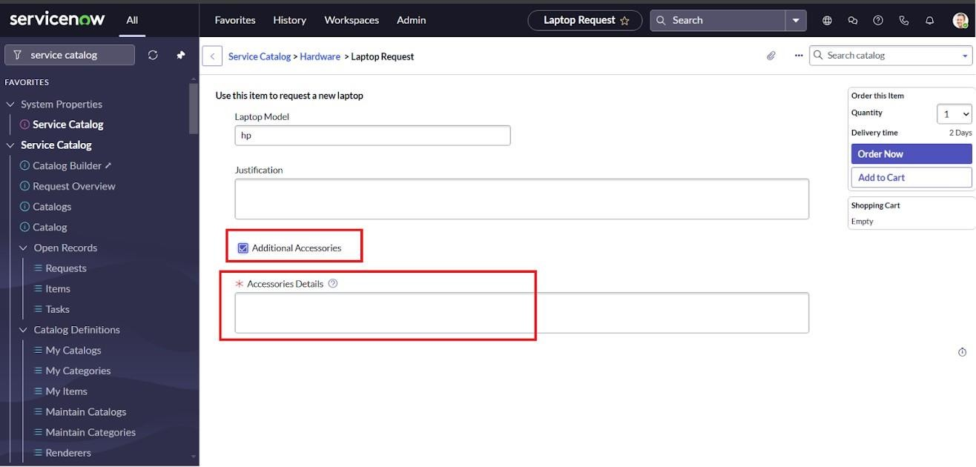

# Conclusion :

The Laptop Request Catalog Item project successfully streamlines the process of requesting laptops within the organization by leveraging ServiceNow's Service Catalog capabilities.

Through the implementation of a dynamic catalog item, the project ensures that users have an intuitive and user-friendly interface, reducing errors and improving efficiency.This project demonstrates how ServiceNow can be used to replace manual, error-prone processes with automated, efficient, and user- centric solutions. It not only improves service delivery but also enhances employee satisfaction by providing a modern and streamlined request experience

.